

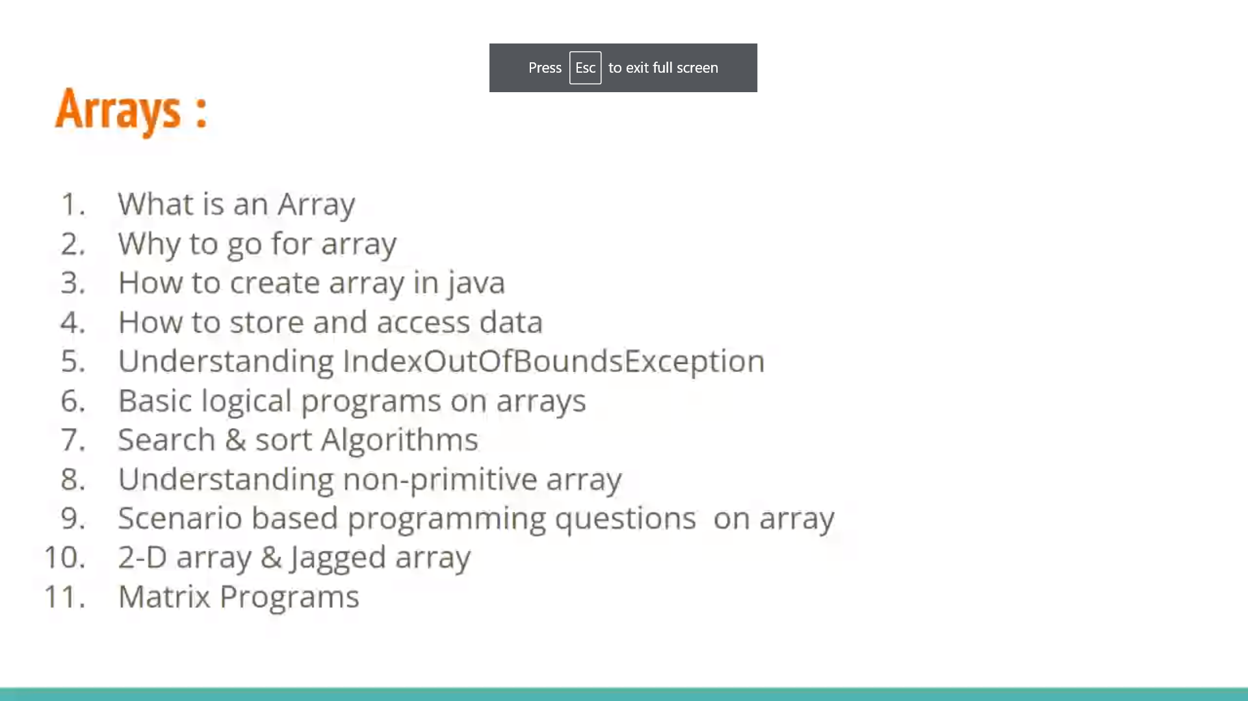

What is an array

Why to go for array

How to create array in java

How to store and access data understanding indexoutboundsexception

basic logical programs on arrays

search & sort algorithms

understanding non-primitive array

scenario based programming question on array

2-D array & jagged array

Matrix programs

Practice & learning

Store – reference

Use – index

What is an array?

Ans. It is a continuous block of memory which is used to store multiple values

* We can store and access the data with the help of array reference and index

Variable is named block of memory

a- is a Array of variable

a is array reference variable which is used to remember

sore address of string array

what should I do?

A create variable or string[] type

What is s??

It is a array ref. variable of string type

Batch vap1

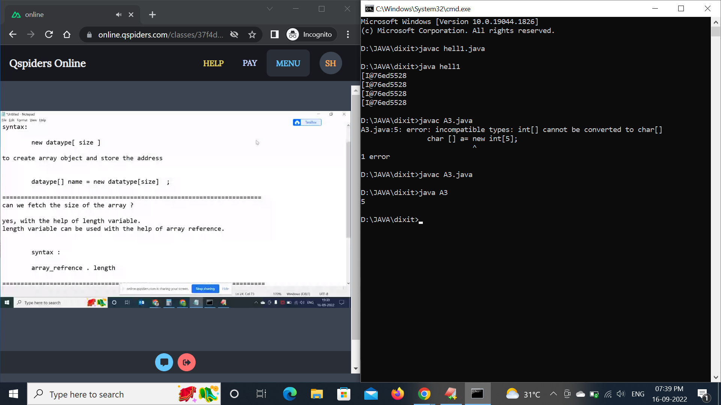

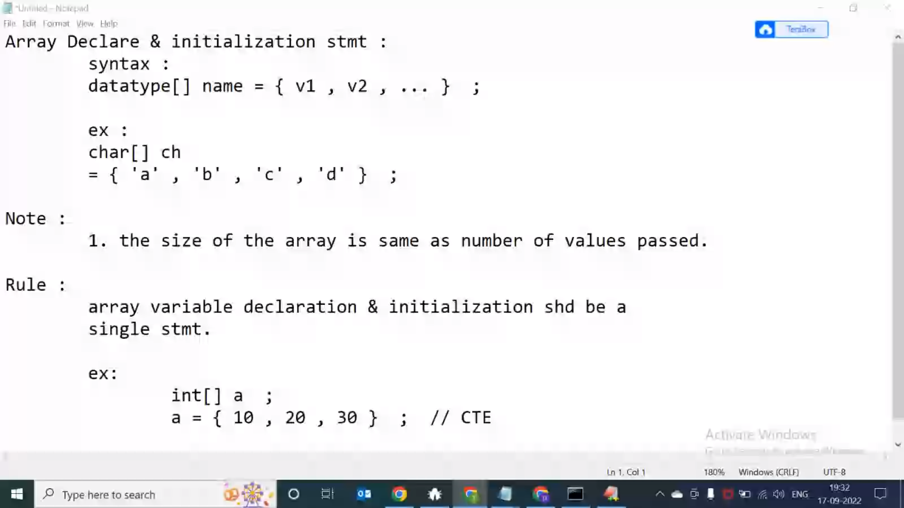

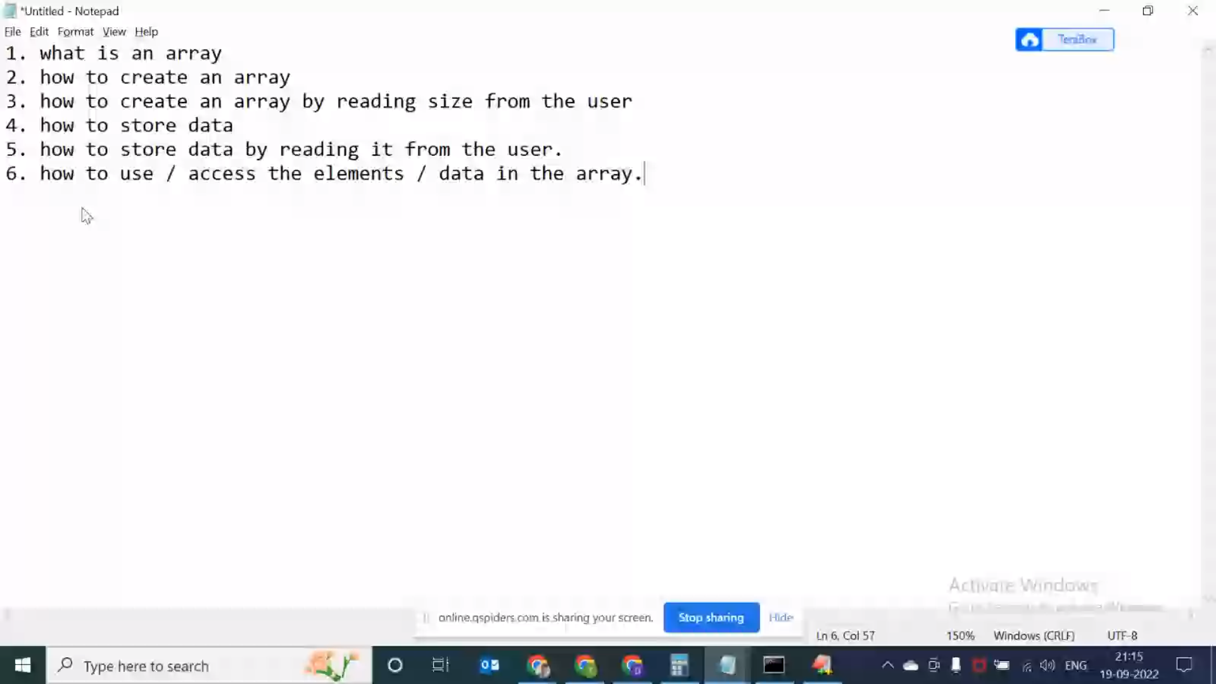

Create a byte array of size n by taking size from user and initialize the data by reading it from the user and print in single line" "Create a short array of size n by taking size from user and initialize the number of values accordingly and print in single line" "Create a int array of size n by taking size from user and initialize the number of values accordingly and print in single line" "Create a int array of size n by taking size from user and initialize the number of values accordingly and print sum of 1st and last elements" "Create a float array of size n by taking size from user and initialize the number of values accordingly and print average of 1st and last the elements" "Create a double array of size n by taking size from user and initialize the number of values accordingly and print difference of 1st and last element" "Create a int array of size n by taking size from user and initialize the number of values accordingly and print product of 1st and last element" "Create a int array of size n by taking size from user and initialize the number of values accordingly and print modulus of 1st and last element

1. what is an array

2. how to create an array

3. how to create an array by reading size from the user

4. how to store data

5. how to store data by reading it from the user.

6. how to use / access the elements / data in the array.

